Economics 410
Intermediate Theory: Price and Distribution
Spring 2018
Instructor: Michelle Sheran-Andrews
Email: sheran@unc.edu
Class Meeting: TuTh 12:30pm – 1:45pm (Section 001)
TuTh 2:00pm – 3:15pm (Section 002)
Classroom: FedEx Global Education Center 1015
Office Hours: 1) Mondays from 9:30-11:30am by appointment in Gardner 200d. Book in advance at http://calendly.com/sheran .
2) Wednesdays from 2:00-4:00pm in Gardner 009. These are open office hours that utilize My Digital Hand to organize students into a queue upon arrival.
Please see Sakai for a complete list of TA and ULA office hours.
Office: 200D Gardner Hall
Prerequisite: ECON 101, and one of MATH 152, 231, STOR 112, or 113
Website: http://sakai.unc.edu

1. Course Description
The purpose of this course is to explore the foundations of Microeconomic theory, focusing on the behaviors of consumers, producers, and the interaction of these agents in the marketplace. The organization of markets and its implications for firm behavior and market equilibrium are also examined. This course is divided into the following three topics:
- Consumer theory: How households make decisions in the face of scarcity and how these decisions vary in response to changes in the economic environment.
- Firm theory: How firms make decisions in the face of scarcity and how these decisions vary in response to changes in the economic environment.
- The organization of markets: How perfectly competitive, monopolistic, monopolistically competitive, and oligopolistic markets are organized and the outcomes of these markets.

The principles covered in this course are building blocks. These building blocks can and will be used in elective courses to analyze many specialized topics. This material cannot be learned passively. A major goal of this course is to teach you to "think" in a manner beyond fact recall. Active thinking and problem solving are essential. Microeconomic theory is a tool learned best by use!

2. Class Expectations
The rule of thumb in college is that you study for at least 2 hours outside of class for each hour you spend in class, so you should spend a minimum of 5 hours per week studying for ECON410. It is highly unlikely that studying “a lot” the week before the exam will make up for not studying enough in the weeks preceding the exam! Most ECON410 students realize that this just doesn’t work in economics or with the way in which I teach and test.

3. Resources

Textbook
The recommended textbook is Microeconomics by David Besanko and Ronald Braeutigam. You do NOT have to purchase the most recent version of this textbook. You might find additional or alternative textbooks helpful in their treatment of the subject matter and the availability of extra problems. If you would like to check-out or purchase a different textbook, most any "Intermediate Microeconomics" textbook will have similar content, and older editions will likely be just as useful as newer additions. In addition, there are a variety of books on 2-hour reserve in the library.

Poll Everywhere
“In-class polls” will be conducted during each class using Poll Everywhere. Participation requires that you have access to a cell phone texting plan or the internet. You must register with Poll Everywhere prior to our first poll on January 18th. Registration instructions can be found by following this link: http://help.unc.edu/help/poll-everywhere-faq/. If you do not register properly, then your polls will not be counted. Be sure under “How should UNC-CH Admin identify you?” that you enter your PID and onyen using the format PID_onyen. This is case sensitive, so use only lowercase letters for your onyen. In-class polls are to be done in class, and it is a violation of the honor code to answer elsewhere.

Calculator
Only a very basic, non-programmable calculator is permitted during exams. If your calculator does not look like the two examples pictured below, it must be approved by me at least 7 days before an exam. The calculator must obviously appear to be basic and non-programmable. NO EXCEPTIONS will be permitted.

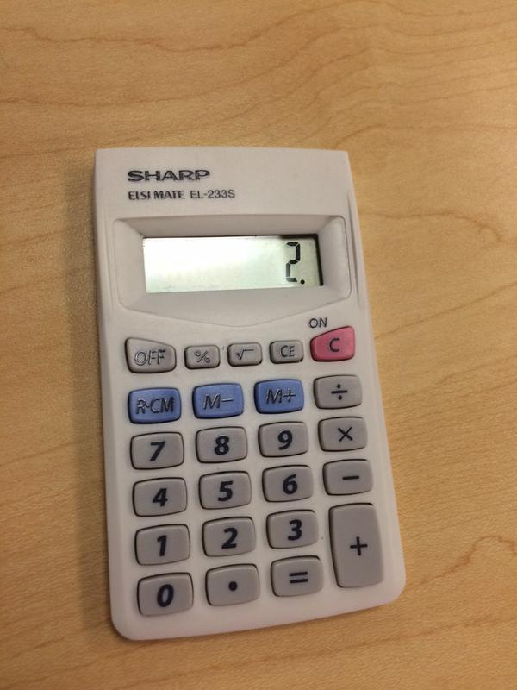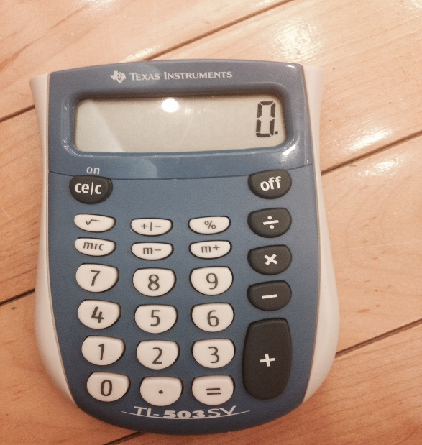

Recitations Sessions
I view recitations as an important part of this course. You are required to register for one recitation session for this course. However, you may attend a recitation other than (or in addition to) the one for which you are registered. By registering for a recitation session, you will be assigned to a graduate TA. This graduate TA will be your first email contact for homework, content and grade related questions. There will be no recitations on January 12 & January 15, March 9 & March 19, March 30 & April 2, and April 27.

Help Sessions
Undergraduate Learning Assistants (ULA’s) will offer weekly help sessions on Tuesday and Wednesday evenings from 7-9pm in Greenlaw 101. Students may drop in during help sessions for any assistance with course content, including homework assignments.

Email Correspondence
Any question regarding homework grades, homework assignments, or the subject matter of the course should be first sent to your recitation TA. If you do not get a satisfactory or timely response, please email me at sheran@unc.edu. All other course related questions should be emailed to me directly. From Monday-Thursday, you should expect a response to your email within 24 hours. From Friday-Sunday and on holidays you should expect a response within 48 hours. Please note if the question is particularly complex, you might be redirected to office hours, a recitation session or a help session.

PowerPoint Slides
PowerPoint slides will be posted on Sakai before the material on the slides is covered in class. During class, I will not talk at a pace that allows you time to copy all the material on these slides. Thus, I strongly recommend that you print out (or copy by hand) these slides in advance. Further note that I will cover material in class that is not on these slides. Therefore, you should not view these slides as a substitute for note taking.

Accessibility Resources & Service
Students registered with the Accessibility Resources & Service (ARS) Office may take their ECON410 exams at ARS. Exams taken at ARS must be scheduled 3 FULL business days prior to the test / exam start time. I will upload the exams to the ARS exam portal, and exams will be scanned by ARS and returned to me via email. It is the responsibility of students who take exams at ARS to ensure they do not exceed their allotted time limit. There will be a 10 percentage point penalty for each 5 minutes over the time limit.

EconAid Center
The EconAid Center is located in Gardner 009. This is where office hours will be held, where students can work on their economics assignments individually or in groups, and where there will be free peer tutoring during the week. The EconAid Center is open from 8am to 8pm every weekday, though ECON 410 staffers will not always be available.
4. Grades
The actual letter grade you earn in this course will be based on a grading scale to be finalized after the final exam. I will provide feedback over the semester on how to interpret your scores so that you know how you are progressing in the course.

Your grade will consist of 4 components. Please note there is and will be no extra credit.

Component | % | Description
In-class Polls | 5% | Your poll grade will be calculated as the average of your highest 85% of poll scores.
Homework  Assignments | 20% | Your homework grade will be calculated as the average of your 7 highest homework scores.
Midterms | 40% | The higher of the two midterm grades will comprise 25% of your course average, and the lower of the two midterm grades will comprise 15% of your course average.
Final | 35% | The final is a cumulative exam consisting of only multiple choice and true/false questions.

In-Class Polls
Starting Thursday, January 18th, you will receive 1 point for a correctly answered poll, 0.5 points for an incorrectly answered poll, and 0 points for an unanswered poll. I understand that you may not be able to participate in some polls because you might miss class, forget your polling device, and/or have a technical difficulty. However, missed polls cannot be made-up. This holds true regardless of your excuse (e.g. university/athletics commitment, job interview, sickness, technical malfunction, etc.). Don’t worry because only the highest 85% of your polls will count toward your in-class polls grade. You can expect approximately 50 polls throughout the semester, which means I will drop around 7 or 8 polls.

Homework Assignments
There will be 8 graded homework assignments. Homework will be submitted and graded through Sakai and Gradescope. More specific instructions will be provided with each homework assignment. You are responsible for ensuring that your homework is properly submitted and clearly legible. Any part that cannot be read will be assigned a zero. Assignments will be due by noon on the due date, and late assignments will be accepted with a 10% penalty until 8pm. At 8:05pm on the day an assignment is due, an answer key will be posted on Sakai.

You may use the following resources to help you complete your HW assignments:
- Anyone taking ECON 410-001 or ECON 410-002 this semester
- Me, ECON 410 TA's, or ECON410 ULA’s
- Any economics book
- Instructional websites, such as www.khanacademy.org.
Any other resource is considered an Honor Code violation. If you have any questions about a particular resource, please ask me prior to using it.
Midterm/Final Exam Policies
There will be no makeup or early exams given for any reason whatsoever. If you miss a midterm and present me with a valid and documented excuse in advance, your one midterm will comprise 35% of your grade and your final exam will comprise 40% of your grade. Valid reasons include a documented medical illness that prevents you from taking the exam, a death in your immediate family, or a documented mandatory court date. If you miss a midterm without a valid and documented excuse in advance you will receive a 0 for that exam.

Per UNC rules, you can only take the Final Exam at an alternative time if you present me with a pink slip from an advisor verifying that you have at least 3 exams in a 24 hour period. If you present me with a pink slip before the last day of classes, you can take the final exam with the other section. Each section will receive a different final exam, and you will be eligible only for the curve (if there is one) applied to the section with which you took the final exam. If you miss the Final Exam and do not have an excuse from the Dean, you will receive a score of 0 on your Final.

Each midterm is exactly 1 hour and 15 minutes. To ensure that each student has the same amount of time, this cutoff is strict. You must close your exam and put your pencil down when the time has expired. If you are observed writing on or looking at your Midterm after the time limit has passed, you will receive a 10 percentage point penalty for each occurrence.

Regrade Requests
All regrade requests must be made through Gradescope within 1 week of the date the assignment’s grade is posted. There will be no exceptions to this rule except in extraordinary circumstances.

SPRING 2018 ECON 410 COURSE SCHEDULE

DATE | TOPIC AND READING ASSIGNMENT | HOMEWORK
Thursday, January 11 | Introduction and Math Review (Mathematical Appendix) | HW #1 assigned
Tuesday, January 16 | Consumer Theory: Budget Constraints (Chapter 4.1)
Thursday, January 18 | Consumer Theory: Preferences and Utility (Chapter 3.1 - 3.3)
Tuesday, January 23 | Consumer Theory: Preferences and Utility (Chapter 3.1 - 3.3)
Thursday, January 25 | Consumer Theory: Constrained Utility Maximization (Chapter 4.2 and Chapter 4 Appendix 1) | HW #1 due; HW #2 assigned
Tuesday, January 30 | Consumer Theory: Constrained Utility Maximization (Chapter 4.2 and Chapter 4 Appendix 1)
Thursday, February 1 | Consumer Theory: Demand (Chapter 5.1) | HW #2 due; HW #3 assigned
Tuesday, February 6 | Consumer Theory: Demand (Chapter 5.1)
Thursday, February 8 | Consumer Theory: Elasticity (Chapter 2.2 and 2.3) | HW #3 due; HW #4 assigned
Tuesday, February 13 | Consumer Theory: Income and Substitution Effects (Chapter 5.2)
Thursday, February 15 | Consumer Theory: Income and Substitution Effects (Chapter 5.2) | HW #4 due
Tuesday, February 20 | OPEN- catch up and review
Thursday, February 22 | Midterm #1 - Consumer Theory
Tuesday, February 27 | Consumer Theory: Extensions (Chapter 4.3)
Thursday, March 1 | Consumer Theory: Uncertainty (Chapter 15.1, 15.2 and 15.3) | HW #5 assigned
Tuesday, March 6 | Firm Theory: Production (Chapter 6.1-6.5)
Thursday, March 8 | Firm Theory: Cost (Chapter 7) | HW #5 due
Tuesday, March 13 | Spring Break
Thursday, March 15 | Spring Break
Tuesday, March 20 | Firm Theory: Cost minimization (Chapter 7, Chapter 8.1 and Chapter 8.2)
Thursday, March 22 | Firm Theory: Cost minimization (Chapter 7, Chapter 8.1 and Chapter 8.2) | HW #6 assigned
Tuesday, March 27 | The Organization of Markets: Profit maximization and Perfect Competition (Chapter 9.1, 9.2 and Chapter 9 Appendix)
Thursday, March 29 | The Organization of Markets: Perfect Competition (Chapter 9.3 and 9.4) | HW #6 due; HW #7 assigned
Tuesday, April 3 | The Organization of Markets: Monopoly (Chapter 11.1, 11.2 and 11.5)
Thursday, April 5 | The Organization of Markets: Monopoly (Chapter 11.1, 11.2 and 11.5) | HW #7 due
Tuesday, April 10 | OPEN- catch up and review
Thursday, April 12 | Midterm #2- Firm Theory
Tuesday, April 17 | The Organization of Markets: Game Theory (Chapter 14.1)
Thursday, April 19 | The Organization of Markets: Oligopoly (Chapter 13.1 and 13.2) | HW #8 assigned
Tuesday, April 24 | The Organization of Markets: Oligopoly (Chapter 13.1 and 13.2)
Thursday, April 26 | OPEN- catch up and review | HW #8 due
Friday, May 4 | Section 01 Final Exam 12-3pm
Monday, May 7 | Section 02 Final Exam 12-3pm

Frequently Asked Questions

"I bubbled in the wrong answers on my Midterm/Final scantron. Can I get partial credit?"
No. Unfortunately, to ensure fairness and remove subjectivity we have to be strict on scantron grading. The answers on your scantron are the answers on which your grade is based, regardless of what is written on the test itself.

"My scantron score was lower than I expected. Could you check to see if the scantron machine graded it incorrectly?"
Email me directly, and I will manually grade your scantron. Make sure to include your name, section, and onyen. Please note scantron grading issues are very rare. (I have literally never seen one.)

"Is there extra credit?"
No. The reason I do not offer extra credit is that if everyone knows about it, it's not really extra credit. It's just another assignment. If some people don't know about it (for instance, if a specific student asks for extra credit at the end of the semester), then I'm treating my students differently, which I make every attempt to avoid.

"I got an 89.8. Is there anything I can do to raise my grade?"
I completely empathize with this question, as I understand how frustrating it is to be close to the cutoff for a particular grade. Unfortunately, however, the answer is no. The reason is twofold. First, I believe selective extra credit leads to an inequality in how I treat different students, which I make every attempt to avoid. Second, with a class of this size, if I move the grade scale down by even 0.1, I am sure to have moved the cutoff up against another student. This once again introduces an element of inequality, as I was willing to move the scale for one student, but not the new student for whom the cutoff now applies.

“I don’t understand why I did poorly on the exam. I knew the information.”
A major goal of this course is to teach you to think in a manner beyond fact recall, a manner that reflects a higher order level of thinking. Understanding both the material from class and solutions to the homework problems is only a first step in mastering the course material! I want you to strive for a higher order level of learning. How can you achieve this?
- Read the Study Tips document posted on Sakai under Resources in the Administration folder and adopt the recommended strategies.
- Read the Help Sheets and watch the videos posted on Sakai.
- Create your own help sheets for concepts on which help sheets have not been provided.
- Discuss concepts, seek feedback and work problems with your classmates and a graduate TA each week during recitations.
- Come to class prepared! At least skim the relevant material before lecture so you have a general idea of the big picture and some familiarity with the terms and concepts and review your notes from the previous class.
- Do the practice problems from the textbook. (Trust me- they are important and often show up on exams.)
- Ask for help when you need it! I am passionate about helping you master the material in ECON410. Please come see me during office hours or set up an appointment to discuss this further at any time. Additionally, this semester I have 7 undergraduate and 6 graduate TA’s. There is a team of us just waiting to help you.

