COMMUNICATION AND INSTRUCTOR PRESENCE

8 LESSONS LEARNED FROM TEACHING ONLINE

Video: EDUCAUSE – 8 Lessons Learned from Teaching Online
In this video, online instructors and higher education professionals provide insight regarding what has worked for them in their unique online teaching environments. These 8 lessons include:
- High-touch is more important than high-tech
- Establish social presence using digital storytelling
- Use technology intentionally
- The power of external resources
- Make your expectations explicit
- Fun, playfulness and the unexpected
- Login regularly
- Personal feedback
Thinking on these lessons learned, what are some ways that you can incorporate the above mentioned methods and approaches in your online course? You may not feel comfortable calling students on the telephone, and that's understandable. How else could you ensure a 'high-touch' experience for your students? How does communication influence student participation? Additional notes below explore the importance of creating a community of inquiry and how social, teaching and cognitive presence effects the overall educational experience.

THE COMMUNITY OF INQUIRY FRAMEWORK
A concern with losing touch with students is common among instructors who are adapting to new modes of digital teaching. Communication and instructor feedback are critical for learning. Just as in a face-to-face course, communication includes both directly conveying information and feedback to the student, as well as more intangible ways of communicating a sense of “being there” as a real human being throughout the course. Because this latter type of communication may not happen organically through the LMS, it's a good idea to create a plan for how, when, and what you want to communicate to students. A significant body of research suggests that social learning and instructor presence are critical for successful learning online (See: Clark & Meyer, 2011; Garrison & Vaughan, 2008; Swan & Ice, 2010; Vaughan, Cleveland-Innes, & Garrison, 2013).
The Community of Inquiry framework, often shown as a Venn diagram (see below) provides a template to translate these findings into practical course design. This framework depicts the educational experience as a function of three overlapping types of presence: cognitive presence, social presence, and teaching presence.

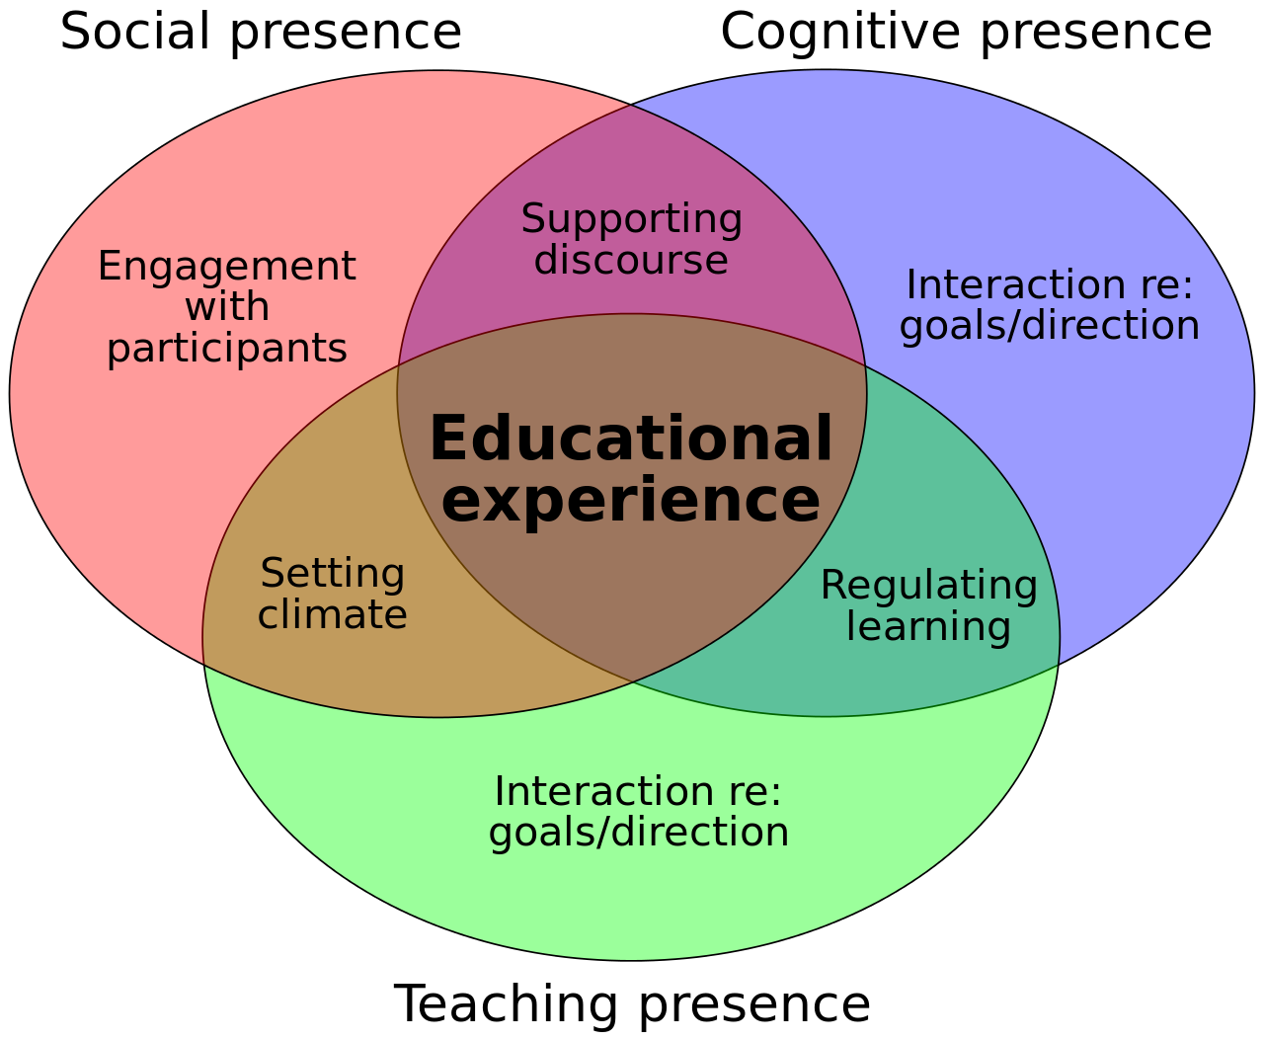
Community of Inquiry Model. Image Source: Wikimedia Commons

Creating Social Presence
Social presence can be described as a feeling of community, connectedness, and degree of connectedness and creating social presence in the online and digital learning environment is critical. It contributes to a successful learning environment by supporting connection and open communication among yourself (instructor) and the learners in the course. This also sets the tone for a collaborative learning experience. You may use a variety of tools and methods to create and maintain a social presence in your online and digital learning environment. Here area few tips to consider when creating a social presence within your course, as identified by Whiteside, Dikkers and Lewis (2014):
- Create connections to build community
  - Example: Add social activities or ice breakers to the synchronous learning environment. When appropriate, use grouping/teams to facilitate community building.
- Understand a variety of tools and media
  - Example: Use tools available to you in a meaningful way. Provide supplemental resources that enhance the learning process.
- Harness reflection and prior experience
  - Example: Integrate authentic storytelling and reflection of experiences into the learning environment.
- Provide early and continuous feedback
  - Example: Offer feedback on academic performance throughout the course and standardized feedback schedules when possible.
- Design with assessment in mind
  - Example: Incorporate a variety of high and low-stakes assessment and activities throughout the course. This helps learners to connect the information in meaningful ways and develop mastery of content.
- Encourage change in small steps
  - Example: Incorporate changes to your online course over time. Allow time to adjust to new methods and frameworks used in the online teaching environment.

Creating Teaching Presence
When there is a diminished teaching/instructor presence in the online and digital learning environment, it can have a negative effect on the learner. This can look like many things: low engagement, diminished quality of work, lack of participation and decreased performance in the course. When designing an online course, it is important to design for teaching presence. Using a variety of instructional methods and tools, you can differentiate your delivery and encourage student engagement through your online and digital presence. Instructional video, changing your default image to a headshot or other image of your likeness, creating and maintaining a consistent communication plan (i.e. announcements, emails, etc.), all of these are ways to increase teaching presence within a course. These can also serve as evidence of engagement and provides a model of your active participation in the course as the instructor. Rob Kelly further explains how creating instructor presence can have a profound impact on student learning in the online and digital learning environment in this article.

Creating Cognitive Presence
Cognitive presence is important for encouraging critical thinking, creative problem-solving and constructing meaning within a course. This occurs among all interactions within a course: student to student and student to instructor. Modeling cognitive presence for students can occur in a variety of places in the online and digital learning environment. Discussion forums, assignments, announcements, synchronous sessions and asynchronous learning activities are all places in which you as the instructor can model cognitive presence. As indicated by the diagram above, the intersection of teaching and cognitive presence results in a concept called regulated learning. Paz and Pereira (2015) further refine this area to include the following activities:
- Confirm student understanding of tasks (feedback)
- Assess learning strategies and work processes and/or propose corrections to those processes (reflection)
- Remind students of tasks and encourage them to focus on or contribute to tasks, resources, and activities (monitoring)
- Assist with tasks, processes, or products of learning by providing access to examples and expectations (modeling)
- Manage the movement through learning phases or tasks within the course (course management and assessment)
Use your best judgement as it relates to the flow of your course, content and rigor as it relates to creating cognitive presence in your online and digital learning environment(s).

